**Objective Questions**

**Q1**) What is the total number of attributes in the customer table?

**Answer)** 3 attributes

**Approach**: - Attributes means columns of a specified table.

**Q2**) How will you get the “Customer’s” ages in the “Order” tables according to customer IDs?

**Answer**) Added in the PBI file

**Approach**: - Add the calculated column in the Orders tab and then use the “Related” function to fetch the age from the Customer sheet using the Customer ID



**Q3**) In analyzing the dataset with Power BI, ensure data cleaning to address inconsistencies and missing values before further analysis.

**Answer**) Removed Null from Location, ProductCategory & Unit Price column in Orders table.

**Removed Nulls**: Filtered out NULL from each column of Orders table

**Changed Data Type**: Converted the **OrderDate** column to a **Date** datatype for better handling and analysis.

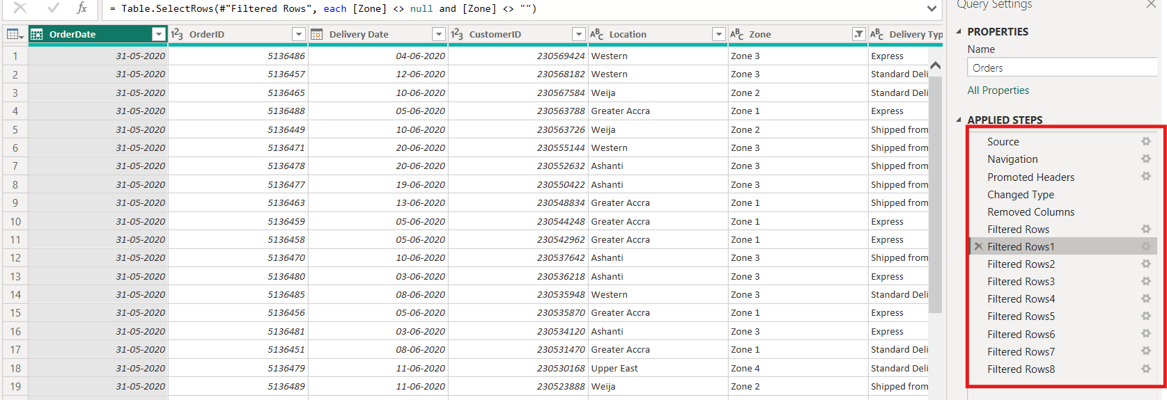

**Q4**) How can we calculate the total revenue generated by all the sales?

**Answer**: 107.24M

**Approach**: Used sum DAX to calculate the total revenue i.e Unit Price * Order Quantity

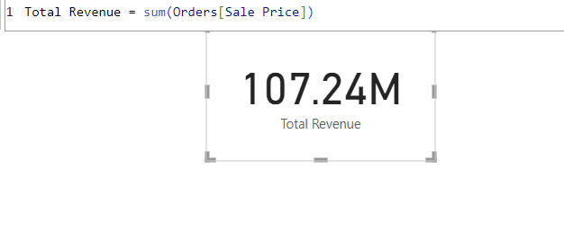

**Q5**) What is the total number of unique customers who made purchases each year? Is there any increase in the number over the years?

**Answer**: Total number of unique customers each year is 113K

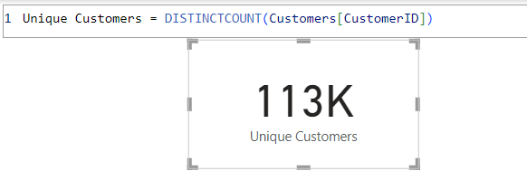

**Approach**: **Unique Customer Count**:

* Used the **DistinctCount** function to identify the number of unique CustomerID entries in the **Orders** table.
* This ensures an accurate count of individual customers without duplicates.

**Observation**:

* **Year-Wise Customer Growth**: The graph reveals a noticeable **increase in the number of customers for the year 2020**.
* **Stagnation Before 2020**: In earlier years, customer growth remained **stagnant**, indicating little to no expansion in the customer base during that period.

This suggests that strategic changes or external factors in 2020 likely influenced customer acquisition positively.

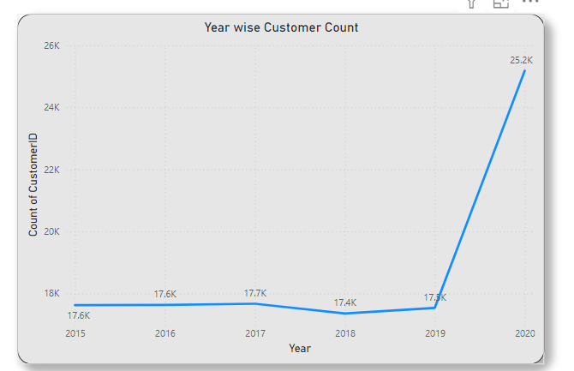

**Q6**) How can we determine the total number of unique products available in the company?

**Answer**: There are 44 unique products available in the company.

**Approach**: Used “Distinct Count” to find the unique product count

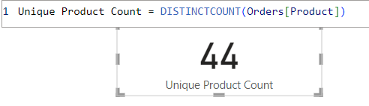

**Q7**) What is the average number of days it takes for products to be delivered, get the metric for only the delivered orders.

**Answer**: It takes 9.41 days for products to be delivered. Get the metric for only the delivered orders.

**Approach**: Used AverageX, Filter & datediff formula to calculate the avg delivery days for the orders which has been delivered.

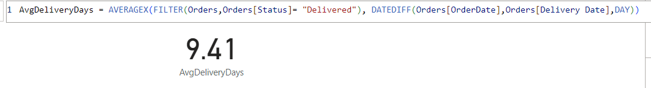

**Q8**) Which products, categories, and subcategories are the most popular?

**Answer**: Below are the most popular items:

Product :- Canon EOS 600D 18MP CMOS DSLR Camera - Black

Categories :- Phones and Tablet

Subcategories :- Digital Cameras

**Approach**: Used Column Chat to create the Visualization for most popular criterias:

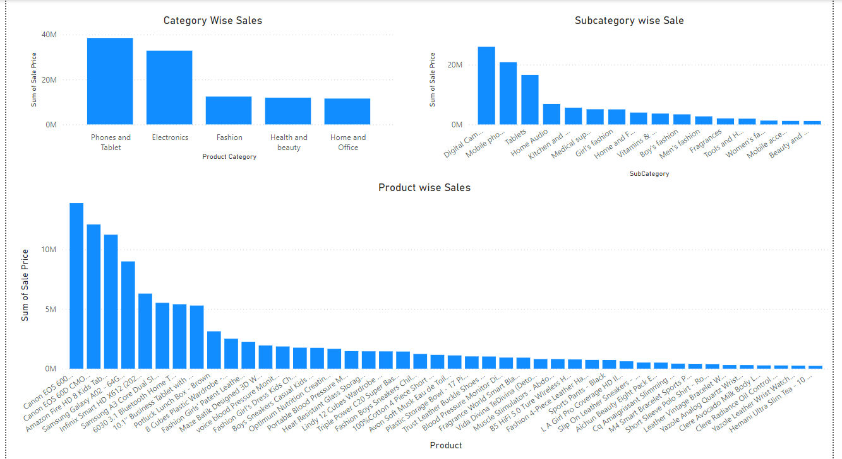

**Q9**) Which products have seen an increase or decrease in sales over the year?

**Answer**: Sales across all products increased from 2015 to 2020, but there were declines in specific years within this period. To gain better insights into these fluctuations, a Year-over-Year (YoY) percentage change view with a product slicer was created. This allows for a more granular analysis of individual product sales trends. The tool helps identify years with sales dips and better understand their causes. These insights can guide strategies for addressing periods of decline and driving sustained growth.

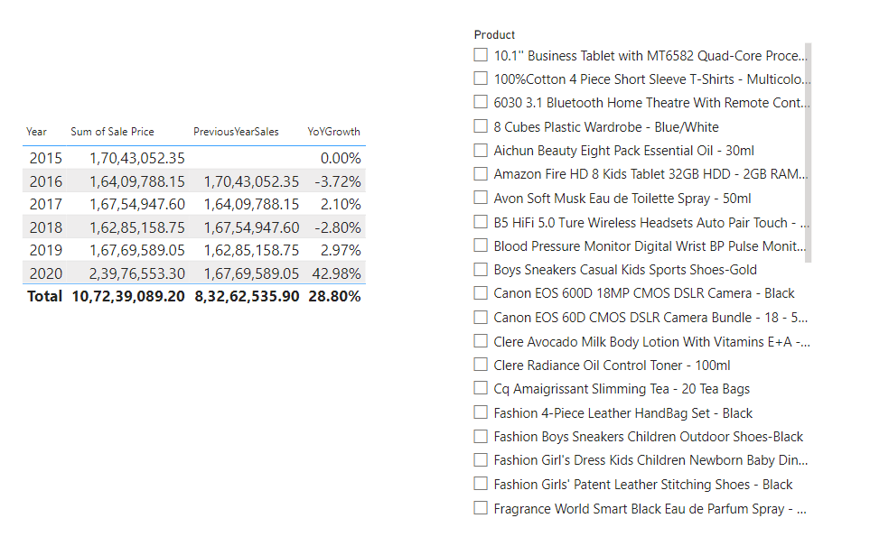

**Q10**) While modeling the data relationships, what will be the type of relationship between the customer ID of Orders and customer tables?

**Answer**: Many to one relationship between Orders and Customer table

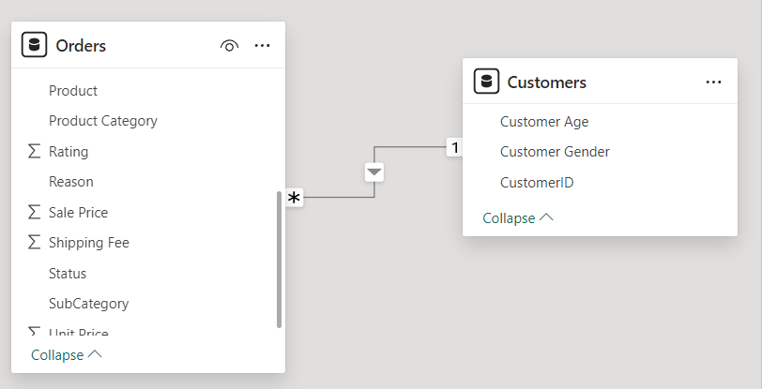

**Q11**) How have you handled the null values in the data?

**Answers**: After excluding the null values from the dataset, the remaining count of data points was too minimal to provide meaningful analysis. This suggests that a significant portion of the dataset had missing or incomplete values. As a result, further steps may be needed, such as imputation or data enrichment, to ensure a more comprehensive and robust dataset for analysis.

**Q12**) Were there any data format issues in the data, and if there were/are how you would handle them?

**Answer**: There was a data format issue with the Order Date and Delivery Date columns, which I corrected by applying the correct "Date" format to both these fields. This adjustment ensured that the dates were properly recognized for analysis, eliminating any inconsistencies and allowing for accurate time-based analysis in the dataset.

For Order Date and Delivery date the datatype was incorrect - hence used the below feature in PBI to change the format type of these columns to DATE

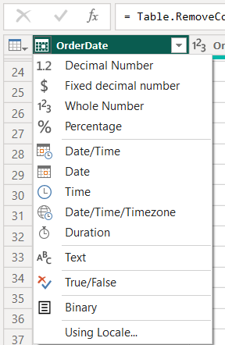

**Q13**)When we add a column in Power Query what’s the code that comes in M language in the formula bar? What do you know about M-query?

**Answer**: If we add a customer column then the formula bar shows something like:

—> Table.AddColumn(PreviousStep, "New Column Name", each <Expression>)

An M-query in Power BI is the code written in the M language, which is used within Power Query Editor for data transformation tasks. M is case-sensitive and supports functional programming. It allows users to perform a wide range of data manipulations, including data import, cleaning, filtering, and reshaping. This enables users to prepare and shape their data before it's loaded into the Power BI model for further analysis and visualization.

Key Concepts of M-Query:

1. **Data Source Connection**: M-queries initiate connections to various data sources, defining how Power BI extracts data from external systems. The source can be files (Excel, CSV), databases (SQL Server, Oracle), web services (APIs), and other data systems.
2. **Transformations**: Once the data is connected, M-queries are used to define the steps of data transformation. Common tasks include filtering rows, merging or appending tables, renaming columns, grouping data, and performing calculations like adding custom columns or changing data types.
3. **Applied Steps**: Every transformation applied in the Power Query Editor results in an “applied step” in the query. These steps are listed in the query pane and are stored as M-code. Each step is executed in sequence, affecting the data progressively.
4. **Code Syntax**: M-code uses a syntax that consists of a sequence of steps. Each step is written as an expression, and the transformations are chained together. The syntax emphasizes clarity and readability, making it easier to track data manipulations.

M-Query in Power Query Editor

1. **Open Power Query Editor**: Access through the "Transform Data" button in Power BI.
2. **Use UI for Transformations**: Perform actions like filtering or merging, which auto-generate M-code.
3. **Advanced Editor**: View or edit the M-code directly by clicking the "Advanced Editor" button.

Benefits of M-Queries

* Customizable: You can manually write or tweak the query for specific requirements.
* Reusable: Copy and adapt M-code for similar data transformations.
* Powerful: Enables complex data transformation and integration tasks.

**Q14**) Identify the top 5 most valuable customers using a composite score that combines three key metrics: (SQL)

1. Total Revenue (50% weight): The total amount of money spent by the customer.
2. Order Frequency (30% weight): The number of orders placed by the customer, indicating their loyalty and engagement.
3. Average Order Value (20% weight): The average value of each order placed by the customer, reflecting the typical transaction size

**Answer**: There are multiple CustomerID with similar Composite Score 5726 - hence used Rank function to pull all the top Composite Score CustomerID

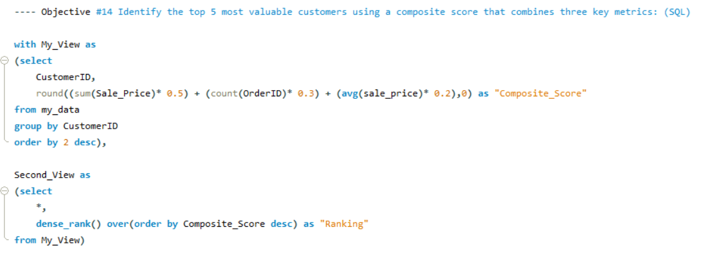

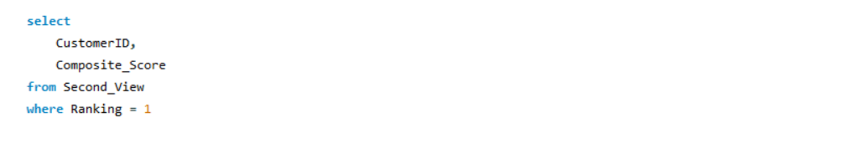

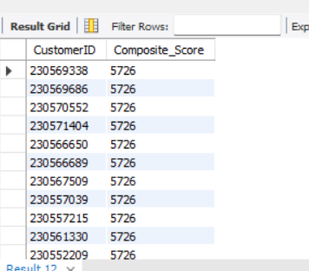

**Q15**) Calculate the month-over-month growth rate in total revenue across the entire dataset. (SQL)

**Answer**: First Created Monthly revenue then created Previous Month revenue using LAG function in SQL, below is the visualized view of the same.

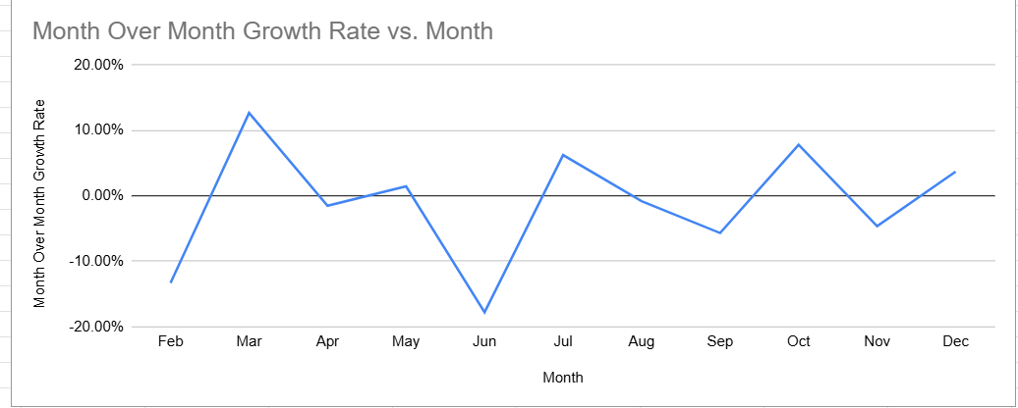

Query:

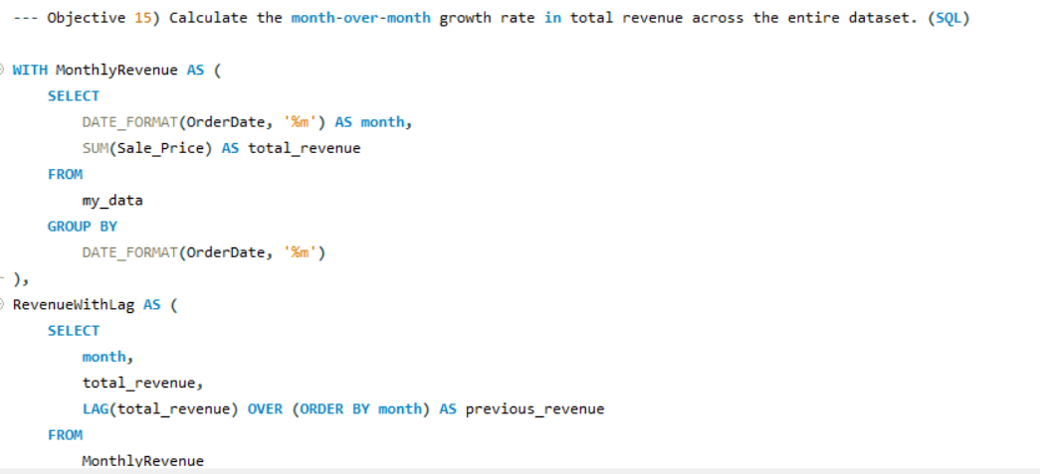

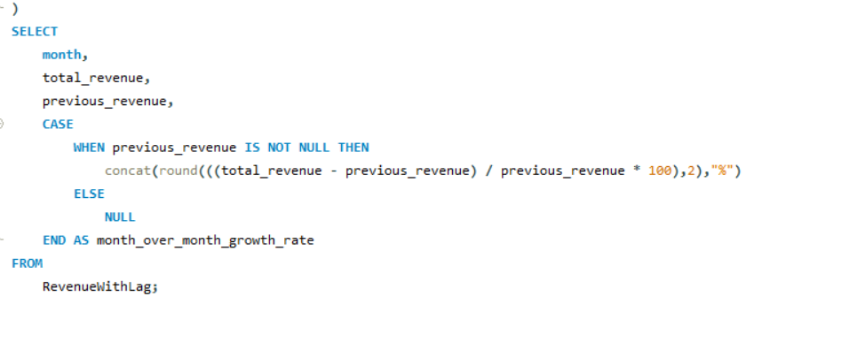

Output:

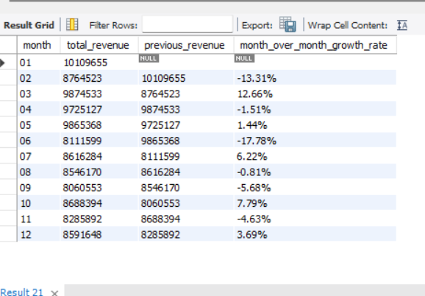

**Q16**) Calculate the rolling 3-month average revenue for each product category. (SQL)

**Answer**: Below Snap shows the 3-month average revenue year-wise for each product category.

**Approach**: First create Month Year column in the Orders table and then create a new Measure : 3 month_avg_revenue with formula :

CALCULATE(AVERAGE(Orders[Sale Price]), DATESINPERIOD(Orders[Month Year],LASTDATE(Orders[Month Year]),-3,MONTH))

Finally used Table view to display the outcome.

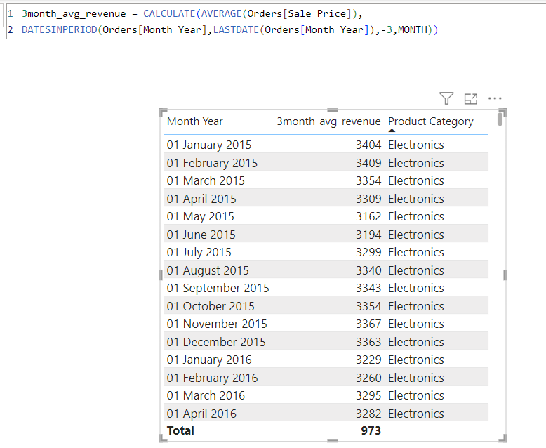

**Q17**) Update the orders table to apply a 15% discount on the `Sale Price` for orders placed by customers who have made at least 10 orders. (SQL)

**Answer**: Since no customer had 10 or more orders, no changes were necessary or applied to the data.

**Approach**: Used the below query to implement this change:

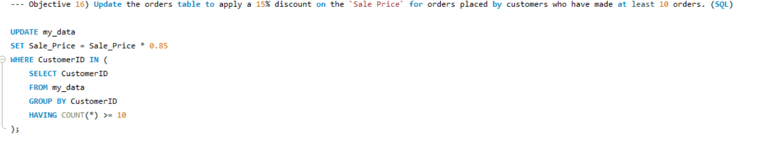

**Q18)** Calculate the average number of days between consecutive orders for customers who have placed at least five orders. (SQL)

**Answer:** Since there are no customers with at least five orders, the output is returning blank.

Query:

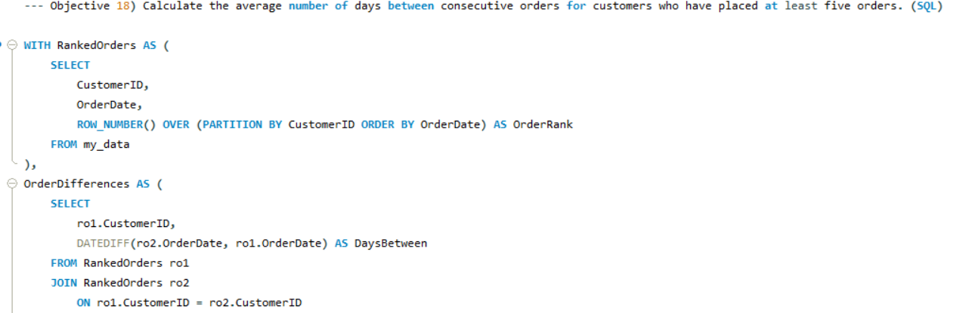

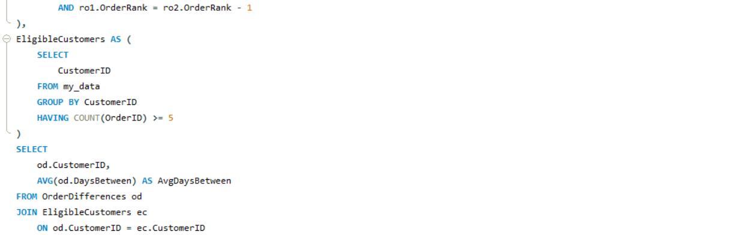

Output:

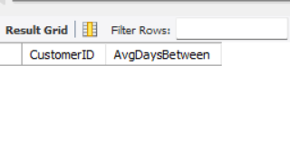

**Q19**) Identify customers who have generated revenue that is more than 30% higher than the average revenue per customer. (SQL)

**Answer**: There are 1000 customers whose revenue is more than 30% higher than the average revenue per customer.

Query: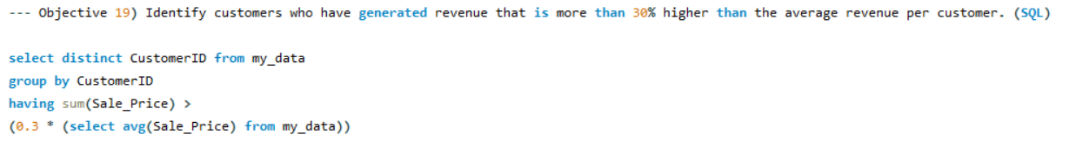

Output:

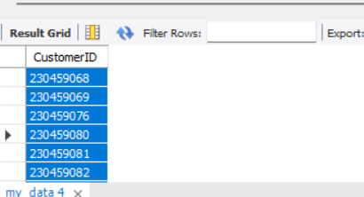

**Q20)** Determine the top 3 product categories that have shown the highest increase in sales over the past year compared to the previous year. (SQL)

**Answer:** Phones and Tablet, Electronics & Fashion are the top 3 products.

**Approach:** Used 2 CTEs - one to create 2019_Revenue and 2nd to create 2020_Revenue and then found the difference and later used limit to find the top 3.

Query:

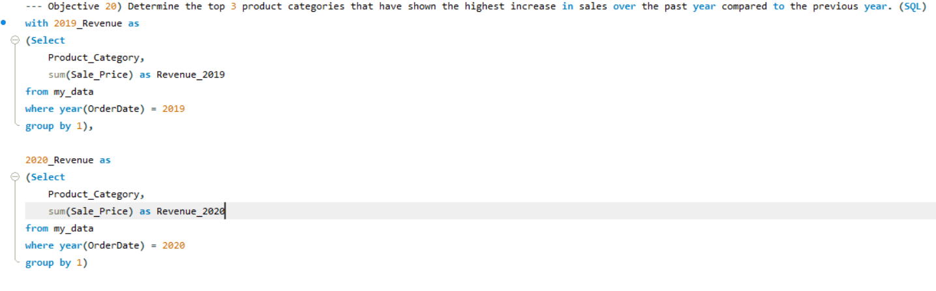

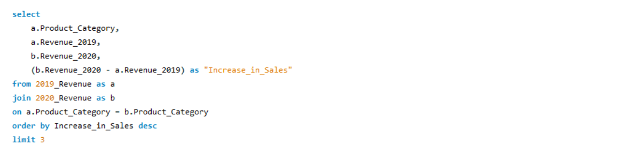

Output:

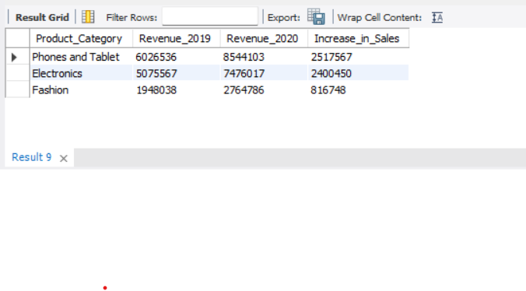

This appears to be a sales data grid showing revenue comparisons between 2019 and 2020 for three product categories:

1. Phones and Tablets: Revenue increased from 6,026,536 to 8,544,103, showing an increase of 2,517,567
2. Electronics: Revenue grew from 5,075,567 to 7,476,017, with an increase of 2,400,450
3. Fashion: Revenue increased from 1,948,038 to 2,764,786, showing an increase of 816,748

All categories showed positive growth, with Phones and Tablets having the largest absolute increase in sales

**SUBJECTIVE QUESTIONS**

**Q1)** Explain the revenue breakdown by year and by-product. Evaluate how different products contribute to annual revenue and come up with suggestions to increase the sales of the low-selling items.

**Answer**: Here are the products that are currently underperforming, as they do not generate annual revenue of at least 100K. To increase their sales, a potential strategy could involve raising their unit prices:

* M4 Smart Bracelet Sports Pedometer Watch
* Short Sleeve Polo Shirt - Royal Blue
* Cq Amaigrissant Slimming Tea - 20 Tea Bags
* Leather Vintage Bracelet Watch - Black
* Yazole Analog Quartz Wrist Watch - Black
* Clere Radiance Oil Control Toner - 100ml
* Clere Avocado Milk Body Lotion With Vitamins E+A - 400ml
* Yazole Leather Wrist Watch - Black
* Hemani Ultra Slim Tea - 10 Bags

Raising the unit price could improve the revenue for these items, but other strategies like promotions, market analysis, and better positioning might also be useful to explore.

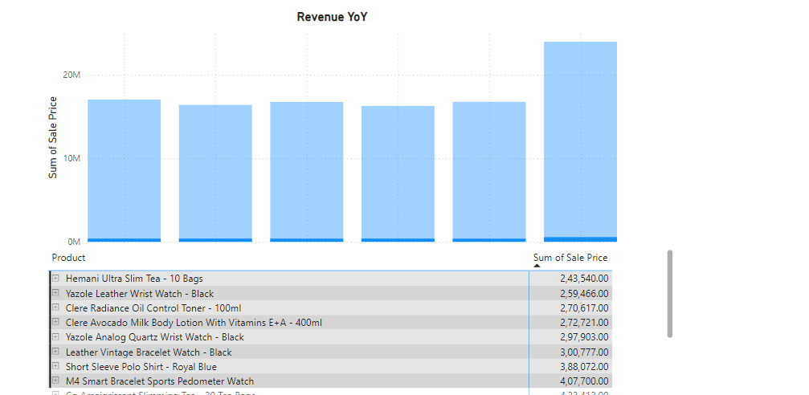

**Q2)** How many products were returned? Use a DAX function to get this metric. Examine the possible reasons for returns and consider how this metric could indicate improvements in product descriptions or quality control.

**Answer**: 31K products were returned.

**Approach**: Used below DAX to calculate the count of returned products. “Returned_Count = COUNTROWS(FILTER(Orders,Orders[Status]="Returned"))”. Then the column chart to plot the reasons for returns.

**Observation**: The total returns amount to 18K, with the majority (58%) being due to "Wrong & Defective" items. This indicates a significant opportunity to reduce returns by improving quality control during dispatch. By implementing stricter quality checks, the number of defective or incorrect products could be reduced. Additionally, improving product descriptions with accurate details can help lower returns by 42%, as it would set correct customer expectations from the start.

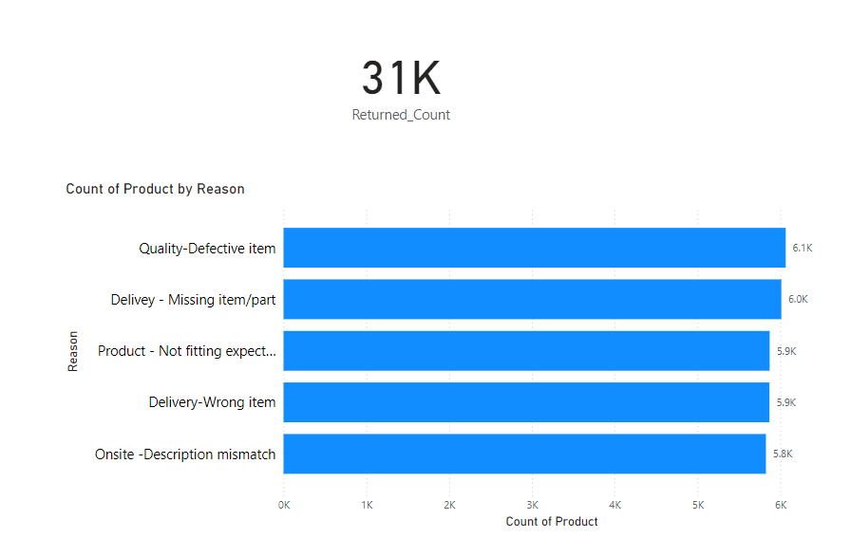

**Q3)** Whenever a customer goes to Amazon, they’ll filter the most rated products to buy the better category. Can you verify this using any visualization or table that the ratings of products impact their sales value?

**Answer**: It seems that the product's ratings aren't affecting the sales value; rather, it's the opposite. Higher sales figures appear to be influencing the ratings, as strong sales often signal quality to customers, leading to more positive feedback.

**Approach**: Used Clustered Bar chart to plot the Ratings on the X-axis and Sale Prices in the Y-axis and then brought the Product Category in Legends.

**Observation**: Ratings are not impacting the sales of the product instead less ratings are showing high sales value in below visualization.

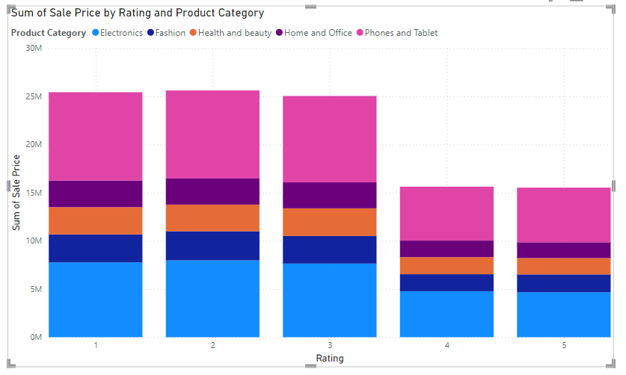

**Q4)** Investigate how revenue distribution varies across different locations. Explore which geographical areas contribute most to sales and consider the strategic implications for regional marketing and distribution efforts. How might location-based trends inform the company's market segmentation and resource allocation approach?

**Answer**: East Africa & Center of North America are the regions with high revenues.

**Approach**: Used Map to fetch the location and used the Sale Price in Bubble field.

**Observation**:

1. **Identifying High-Performing Locations**: Areas with consistently high revenue suggest strong market demand, effective sales strategies, and good customer engagement. These regions likely represent key growth areas.
2. **Recognizing Underperforming Locations**: Locations with lower or declining revenue may highlight untapped market opportunities, competition, or lack of effective marketing and awareness. This signals the need for strategic improvement or targeted efforts.
3. **Regional Preferences for Products/Services**: Certain locations might have distinct preferences for specific product categories or services. Analyzing regional patterns can provide insights into local tastes and guide inventory or promotional decisions.
4. **Seasonal Trends**: Fluctuations in revenue may reflect seasonal demand or cultural events specific to each location. These insights could help tailor offerings to local seasons or holidays, improving sales during peak periods.
5. **Urban vs. Rural Distribution**: Urban areas typically show higher sales due to greater population density and purchasing power. Rural areas, on the other hand, may exhibit slower growth, offering an opportunity for targeted strategies to boost engagement in these regions.
6. **Cost Efficiency in Operations**: The relationship between revenue and operational costs in various locations can reveal inefficiencies. Locations generating high revenue but with disproportionately high operational costs may need a review of their business models or cost-saving measures.

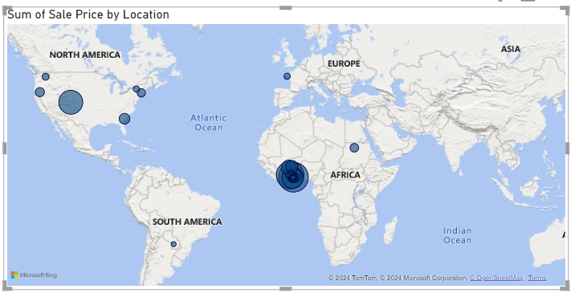

**Q5)** Determine which month could benefit from enhanced promotional offers to boost sales. Can you suggest some targeted marketing strategies here?

**Answer**: June, September and November are the months with less revenue so we should plan promotional offers in this period.

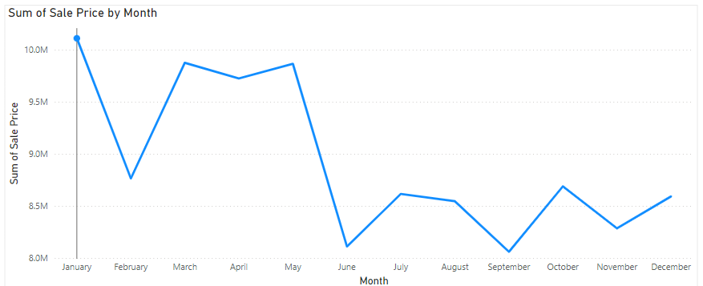

**Approach**: Used Line Chart to plot Months in X-Axis and Sales in Values.

**Observation**:

**1. June (Mid-Year Slowdown)**

**Target Audience**: Customers preparing for summer or mid-year activities.

**Strategies**:

* **Summer Sales Event**: Highlight seasonal items such as summer clothing, outdoor gear, and travel essentials with time-limited discounts.
* **Pre-Vacation Bundles**: Offer vacation or holiday packages with discounts or add-ons for customers planning summer getaways.
* **Engage with Influencers**: Collaborate with influencers to promote summer-themed products on social media platforms to increase visibility and engagement.
* **Loyalty Rewards**: Enhance customer retention by doubling loyalty points for purchases in June, encouraging more frequent spending and increasing overall sales.

**2. September (Back-to-School/Pre-Holiday Dip)**

**Target Audience**: Students, parents, and professionals adjusting to post-summer routines.

**Strategies**:

* **Back-to-School Promotions**: Offer discounts on school supplies, electronics, and educational tools, especially for students and parents shopping for the new academic year.
* **Pre-Holiday Sneak Peek**: Generate anticipation for the upcoming holiday season with early bird offers and sneak peek promotions, encouraging early shoppers to prepare for the holiday rush.

**3. November (Pre-Holiday Lull)**

**Target Audience**: Shoppers preparing for year-end festivities but hesitant to spend before Black Friday or holiday sales.

**Strategies**:

* **Pre-Black Friday Teasers**: Build excitement for Black Friday by offering limited-time deals or sneak peeks at upcoming discounts.
* **Gift Guide Campaigns**: Curate gift guides tailored to different demographics (e.g., gifts for parents, tech lovers, etc.) to help customers with early holiday shopping.
* **Free Shipping Offers**: Encourage purchases by promoting "Free Shipping Week" deals, removing potential barriers to shopping and incentivizing early holiday spending.

**Q6)** Identify which products may require increased marketing efforts. Which items have high prices yet underperform in sales?

**Answer**: Below are the products which will require increased marketing efforts

* Samsung Galaxy A02 - 64GB HDD - 3GB RAM Smartphone - Black
* Infinix Smart HD X612 (2021) - 32GB HDD - 2GB RAM - Black
* Samsung A3 Core Dual SIM - 16GB HDD - 1GB RAM - Blue
* 6030 3.1 Bluetooth Home Theatre With Remote Control - Black + Free Smartwatch
* 10.1'' Business Tablet with MT6582 Quad-Core Processor

**Approach**: Items with Unit Price above 300 were filtered and then Sales Price was plotted in Visualization - above mentioned products are having high unit prices but sales price below 10M

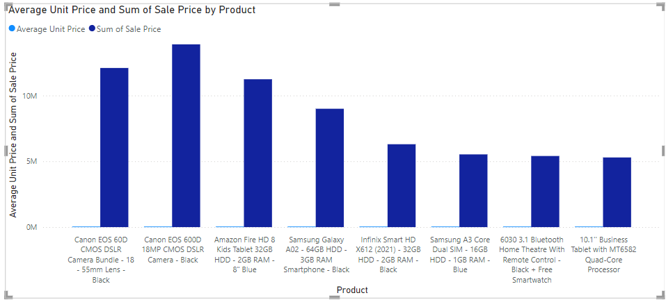

**Observations:**

1. **Premium Products (Cameras)**: The top-performing products in terms of total sales are the more expensive camera models. Despite their higher price points, they are still the key revenue drivers, likely due to strong brand appeal, market demand, or seasonal purchasing behavior.
2. **Middle-Tier Electronics**: While the mid-range smartphones and tablets (Samsung Galaxy, Infinix, etc.) perform reasonably well, they don't reach the same total sales values as the cameras, indicating that, even though they sell in larger quantities, their overall sales value remains lower because of their lower unit prices.
3. **Lower-Tier Products**: The budget products like the **Samsung A3 Core** and **Business Tablet** perform at a much lower sales level, which might be a result of limited consumer interest or lower market demand for these specific models.

**Q7)** Assess which products should have discounts. How can targeted incentives drive sales and customer loyalty for specific products?

**Answer**: Below products should have discounts

* Samsung Galaxy A02 - 64GB HDD - 3GB RAM Smartphone - Black
* Infinix Smart HD X612 (2021) - 32GB HDD - 2GB RAM - Black
* Samsung A3 Core Dual SIM - 16GB HDD - 1GB RAM - Blue
* 6030 3.1 Bluetooth Home Theatre With Remote Control - Black + Free Smartwatch
* 10.1'' Business Tablet with MT6582 Quad-Core Processor

**Approach**: Below items in visualization have high unit price but above mentioned products have not crossed 10M sales - hence we can create discounts for these products.



Observation:

**Samsung Galaxy A02 (64GB HDD, 3GB RAM, Black)**

* **Trade-In Discounts:** Encourage customers to exchange older phones for discounts.
* **Bundled Accessories:** Provide value with a free phone case or screen protector.
* **EMI Offers:** Enable easier payment options with zero-interest financing.

**Infinix Smart HD X612 (2021, 32GB HDD, 2GB RAM, Black)**

* **Loyalty Points:** Double loyalty points to incentivize repeat purchases.
* **Seasonal Discounts:** Offer a targeted discount for the "Back to School" season.

**Samsung A3 Core Dual SIM (16GB HDD, 1GB RAM, Blue)**

* **Localized Promotions:** Offer region-specific discounts where dual-SIM is in demand.
* **Extended Warranty:** Provide an extended warranty for added value and trust.
* **Buy-One-Get-One Offer:** Appeal to families by offering discounts on second purchases.

**6030 3.1 Bluetooth Home Theatre with Remote Control (Black) + Free Smartwatch**

* **Bundle Discounts:** Create bundle deals with complementary products like TVs or gaming consoles.
* **Limited-Time Flash Sales:** Increase urgency and drive immediate sales with short-term promotions.

**10.1" Business Tablet with MT6582 Quad-Core Processor**

* **Corporate Discounts:** Offer bulk purchasing discounts to businesses or educational institutions.
* **App Trials:** Provide free trials for productivity apps or cloud services to add value for business users.

**Q8)** Come up with a loyalty program to benefit the company’s customers. From the available lot of customers come up with strategies to bucket them and provide benefits under different loyalty programs.

**Answer**: I have created a new column “Customer Tier” which categorizes customers on the amount of the sales they create.

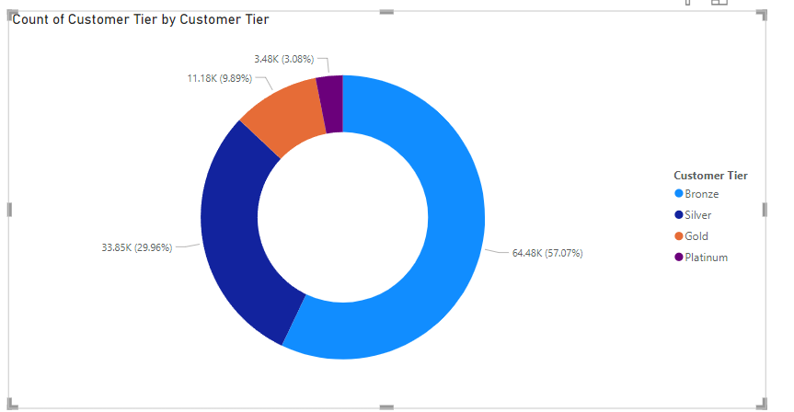

**Approach**: Created a Donut chart for visualization.

**Observation**:

**Platinum Tier: Sales over 5K**

* **Benefits**:
  + **Highest Discounts**: Exclusive access to the best discounts across products.
  + **Birthday Offers**: Special gifts or discounts for customers celebrating birthdays.
  + **Exclusive Invites**: Invitations to product launches or VIP events, create a sense of exclusivity.
  + **Free Gifts**: Complimentary gifts for top customers to enhance loyalty.

**Gold Tier: Sales over 2K**

* **Benefits**:
  + **Higher Discounts**: Discounts on various products, slightly lower than Platinum but still substantial.
  + **Personalized Offers**: Tailored promotions based on customer preferences and shopping behavior.
  + **Free Shipping**: Enjoy free shipping on all orders, encouraging more purchases.
  + **VIP Customer Service**: Priority customer support to ensure a premium experience.

**Silver Tier: Sales over 500**

* **Benefits**:
  + **Product-Specific Discounts**: Special discounts on selected products to encourage more targeted purchases.
  + **Exclusive Offers**: Access to time-sensitive sales, special promotions, or loyalty rewards.
  + **Early Access to Sales**: The ability to shop during early access periods, securing the best deals before the general public.

**Bronze Tier: Sales under 500**

* **Benefits**:
  + **First-Time Purchase Discount**: A discount on the first purchase to incentivize customer acquisition.
  + **Loyalty Points**: Earn points on the next purchase, building loyalty and encouraging repeat buying.

**Q9)** Using the DAX functions Calculate and a row iteration DAX function calculate the total sales for the Product Category “Fashion” and delivery type “Shipped from Abroad”. What are the other types of DAX functions you have used in the project?

**Answer**: 4.14M is the revenue under this filter.

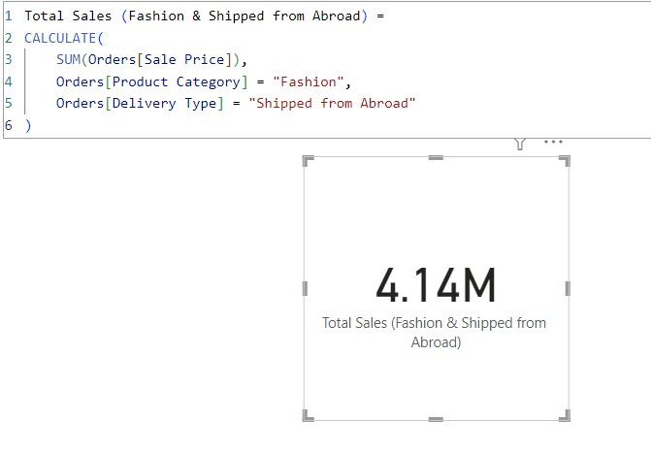

**Q10)** Wait Times Correlated with Demographics and Care: Explore how average wait times vary across different product categories to optimize scheduling and staffing.

**Answer**: Average Delivery Days is same across all Product Category i.e 10 days.

**Approach**: First calculated the wait time by creating a new column : Delivery Days with datediff function. And then used Column Chart to plot the Category wise Average Delivery Days.

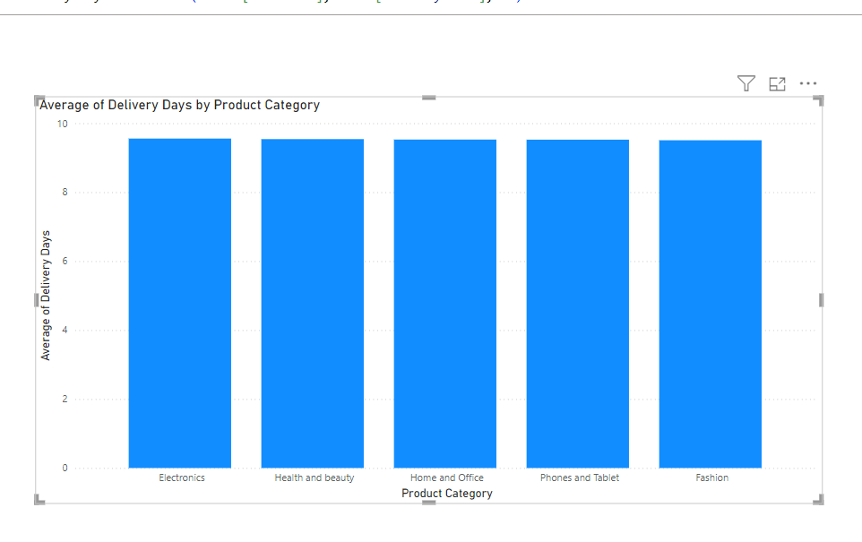

**Q11)** Explore if there is any relationship between the Delivery type and waiting time between ordering and receiving an item.

**Answer**: Yes, Express Delivery Type’s wait time is very less as compared to the remaining types.

**Approach**: Used Column Chart to plot the Avg Delivery Days and Delivery Type view.

**Observation**:

2 **Express Delivery**:

* **Delivery Time**: Products are delivered within **4 days**.
* **Key Insight**: This is a fast and efficient delivery option, likely to appeal to customers who prioritize speed and convenience. It ensures quick access to products, enhancing customer satisfaction and encouraging repeat purchases.

1 **Shipped from Abroad**:

* **Delivery Time**: Takes approximately **15 days**.
* **Key Insight**: Products shipped from abroad experience a longer wait time due to international shipping processes, customs, and other logistical factors. While this may cause some frustration, it’s common for items from international markets. The longer delivery time may impact customer expectations, making it essential to clearly communicate estimated delivery times at the point of purchase.

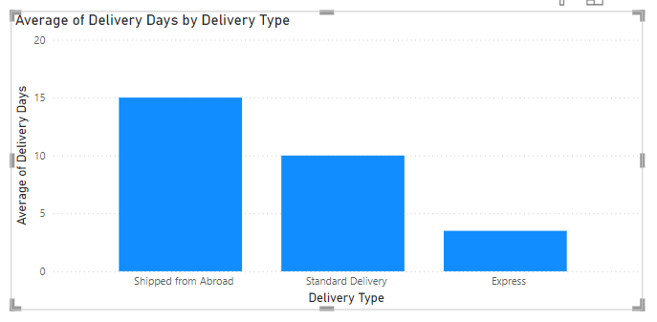

**Q12)** Is there any relationship between shipping charges and product type?

**Answer**: Shipping Charge is the same across all Product Type, no change is seen

**Approach**: Used Column Chart to plot the Shipping Fee and Product Category in Column Chart.

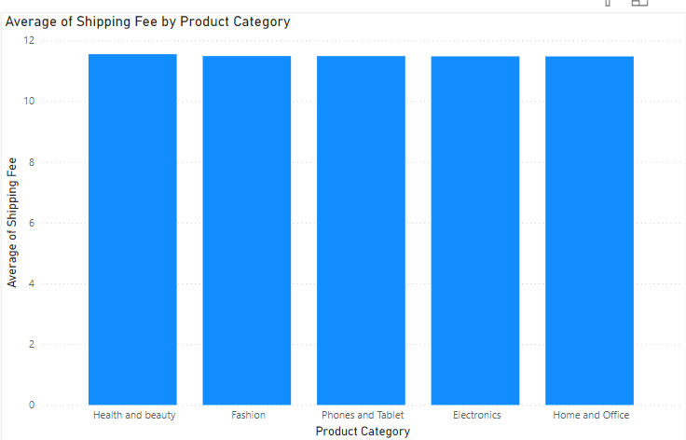

**Q13)** Come up with strategies to decrease the low rating orders after analyzing different factors like waiting time, shipping type, unit price, etc.

**Answer**: Below visualization shows the difference between each of the metrics for lower ratings (<3 ratings) and high rated orders (4&5 ratings).

**Observation**:

**1.** **Wait Time and Ratings:**

* **Observation:** Wait time doesn't impact ratings.
* **Action:** Focus on improving delivery speed (Express shipping), packaging, and communication to enhance customer satisfaction.

**2.** **Shipping Type Impact:**

* **Observation:** "Shipped from Abroad" may lower ratings due to delays and higher costs.
* **Action:** Promote Express Shipping and offer premium express options for international products to improve delivery and ratings.

**3.** **Average Unit Price and Ratings:**

* **Observation:** High unit prices may negatively impact ratings.
* **Action:** Adjust pricing with discounts or bundles to improve perceived value, and test different pricing strategies to optimize sales and ratings.

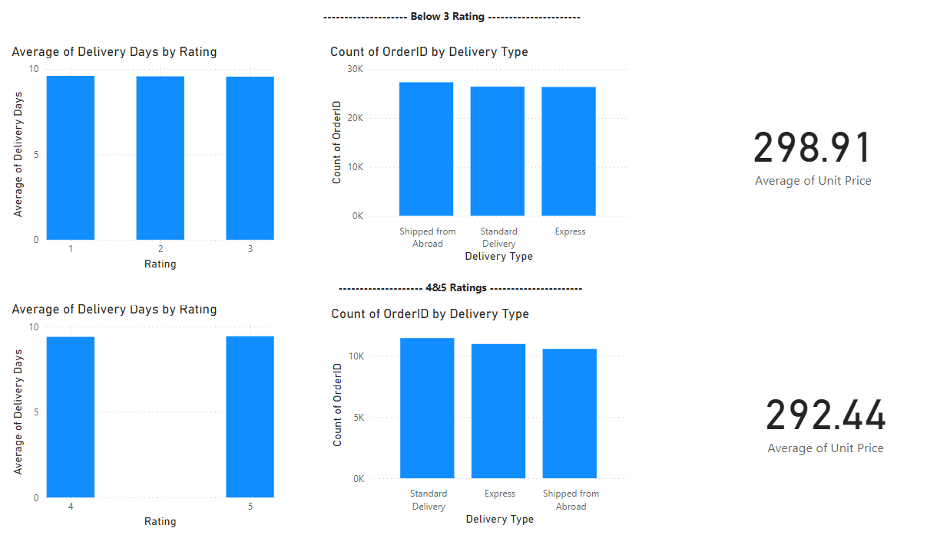

**Q14)** Using the time intelligence DAX function, create a table to compare each month’s sales with the previous year’s same month’s total sales. So there will be four columns in the output year, month, total sales, previous_years_sales.

**Answer**: Created DAX “Previous_Year_Sale” with below formula.

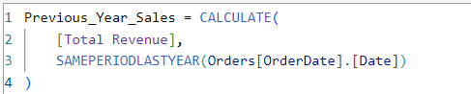

**Approach**: Created Table where Month-wise previous year's same period sale is plotted in the table.

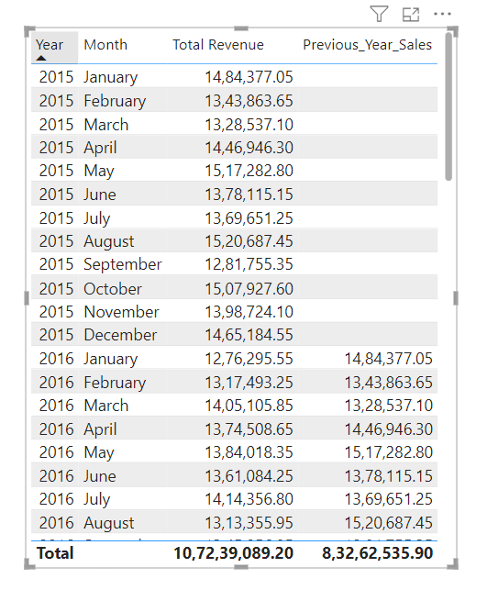

**Q15)** What do you understand by PowerBI gateway? What are its use cases?

**Answer**: A **Power BI Gateway** acts as a secure bridge between on-premises data sources and the Power BI cloud service. It allows you to connect data sources like SQL Server, Excel, or other on-premises databases to Power BI, enabling you to refresh datasets, create reports, and publish dashboards.**Key** Here’s a refined summary of **Power BI Gateway Use Cases and Benefits**:

**Use Cases:**

1. **Scheduled Data Refresh:** Automates the refresh of Power BI reports using the latest on-premises data.
2. **Live Data Access:** Enables real-time querying of on-premises data for immediate insights.
3. **Hybrid Data Models:** Combines on-premises and cloud data for a unified view across platforms.
4. **Secure Data Transfer:** Ensures data is securely encrypted during transfer between local sources and the cloud.
5. **Collaboration:** Allows teams to share and access the latest reports, facilitating better decision-making.
6. **File Access:** Connects local files (e.g., Excel, CSV) to Power BI, expanding data integration.

**Benefits:**

1. **Automation:** Automatically updates reports, ensuring data is always current.
2. **Security:** Safeguards data by keeping it within the network and ensuring secure communication.
3. **Versatility:** Supports a variety of data sources, making it adaptable for different needs.

**Q16)** How would you approach this problem, if the objective and subjective questions weren't given?

**Answer**: I would have used the below approach:

**Sales Performance:**

1. **Total Sales Breakdown:**
   * Analyze total sales by **year, zone**, **product category**, and **subcategory**.
2. **Top-Selling and Underperforming Products:**
   * Identify **top-selling products** and those that are underperforming.

**Customer Behavior:**

1. **Order Metrics:**
   * Assess **order frequency**, **average order value**, and **preferred product categories/subcategories**.
2. **Customer Segmentation:**
   * Segment customers by **location**, **order quantity**, and **ratings** for deeper insights.

**Delivery Efficiency:**

1. **Average Delivery Time:**
   * Calculate **average delivery days** across different **zones** and **delivery types**.
2. **Delivery Delays and Trends:**
   * Identify **late delivery trends** by comparing "Delivery Days" against "Status".
   * Analyze the impact of **delivery delays on customer ratings** to gauge satisfaction.

**Revenue Analysis:**

1. **Revenue Breakdown:**
   * Dissect revenue by **unit price**, **shipping fees**, and **sales price**.
2. **Profitability Analysis:**
   * Analyze the **profitability of product categories** by comparing **sales price** against **unit price**.

**Order Status and Cancellations:**

1. **Order Completion and Cancellations:**
   * Track the proportion of **completed**, **canceled**, and **returned** orders.
2. **Cancellation and Return Reasons:**
   * Investigate the reasons for cancellations or returns by **product category** and **subcategory**.

**Seasonality and Trends:**

1. **Sales and Delivery Variations:**
   * Examine how **sales**, **ratings**, and **delivery times** vary by **month** or **year**.
2. **Peak Order Periods:**
   * Identify **peak order periods** and analyze their impact on **delivery efficiency** and **customer satisfaction**.